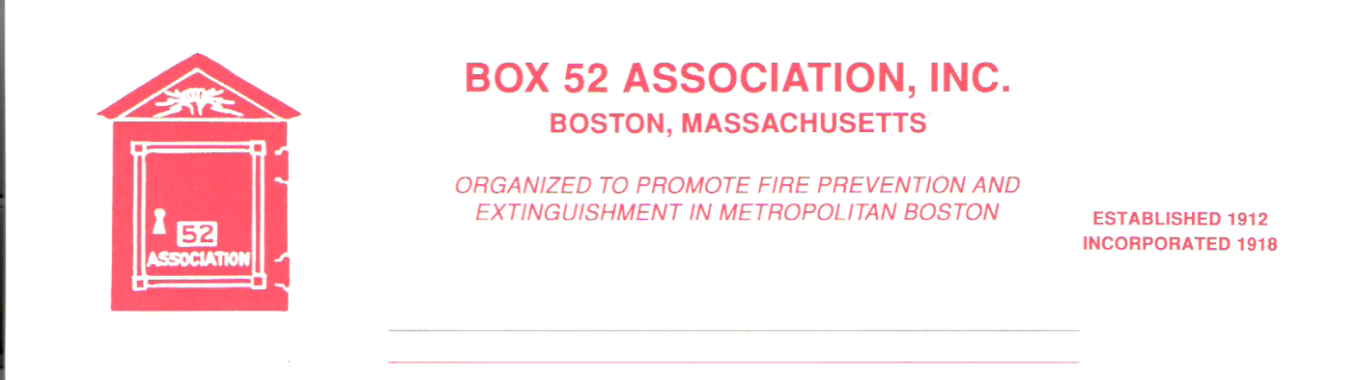
OFFICERS DIRECTORS
PRESIDENT Richard A. Conway Frank Barry
richardaconway@comcast.net Thomas Brophy
VICE James Cullen Michael Kass
PRESIDENT jandm0603@hotmail.com Patrick O’Connor
SECRETARY Jeff Brown David Parr
box52 secretary@gmail.com John Rafferty
TREASURER William H. Wilderman – 617-212-8186
Bwilderman@feinewengland.com
Mailing Address:
Box 52 Association
Website: www.Box52.org c/o William H. Wilderman
E-Mail: box52boston@hotmail.com PO Box 848
Medford, MA. 02155-0009

Celebrating the sesquicentennial of the sounding of Box 52 November 9th, 1872

General Order # 1,072 March, 2022

DATE: Friday March 18th, 2022

LOCATION: St. Teresa of Calcutta Church
Former St. Margaret’s
800 Columbia Rd. Dorchester
Nearest box 7252 Columbia Rd & Dorchester Ave.

TIME: 2000 Hours Meeting
Due to the church holding Lenten Stations of the
Cross, members are asked to arrive after 1945
hours!

PROGRAM: Guest Speaker William Ladell FDNY Dispatcher
Assigned to the Field Comm Unit.

February Meeting
38 members and guest were logged into Zoom for the meeting with our guest Mr. Vito Maggiolo the PIO of the D.C. Fire & EMS Department. Vito presented his duties and then answered many questions about the District of Columbia Fire operations.

March Meeting
With our March meeting we are resuming in person meetings! Our meeting will take place in Boston at St. Teresa of Calcutta Church 800 Columbia Rd. This is the former St. Margaret’s. Parking can be found in the rear of the church on Roseclaire St. It is okay to load up the rear lot. Entry door on the B/C corner. Please do not arrive prior to1945 hours to allow parishioners to leave following the Lenten Stations of the Cross. Additional parking is across the street in the front school parking lot on Columbia Rd.
Our guest will be Mr. William Ladell a longtime FDNY Dispatcher who is presently assigned to the Field Comm. Mr. Ladell has had a very interesting career with the FDNY Communications Bureau. It promises to be a most interesting evening. Please make every effort to attend this in person meeting.

Membership
The first reading of applicant David Traiforos will be read at the March meeting. The second reading and vote for membership will take place at the April meeting.

By Law Announcement
Per the Association’s Bylaws, at the April meeting the membership will be asked to vote on moving the sum of $ 2,000.00 from the Permanent Fund to the Operating Fund to cover Audio-visual equipment to allow the live streaming of meetings and to cover expenses that are not covered by dues.

Ham & Bean Supper
The Ham & Bean supper will be on May 20th at the Erie No. 4 in Georgetown. The guest speaker will be Mr. James Regan of Chicago who will be presenting another interesting and informative show. Ticket will be on sale at the March meeting and the cost will be $ 15.00 per person. See Treasurer Bill Wilderman for your ticket(s)!

Bus Trip
The bi-annual bus trip will be held on Saturday June 11th and we will be touring the southern tier Metro Departments and a few other seaside communities. More info will be forthcoming.

Reminders

- Friday March 18th in person meeting 2000 hrs. St Teresa of Calcutta 800 Columbia Rd.
With guest speaker FDNY Dispatcher Bill Ladell. Do not enter until 1945 hrs!
- Tickets for the Ham & Bean Supper on sale $ 15.00 per person

By Order of the President Newsletter Editor
Richard Conway Frank San Severino

