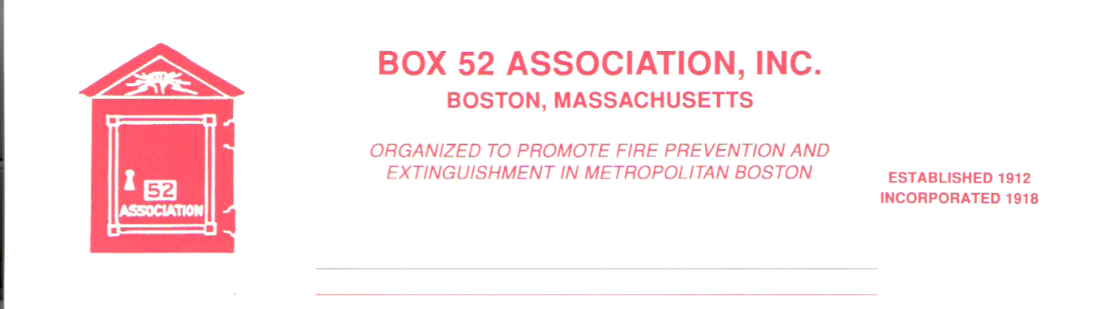
OFFICERS DIRECTORS
PRESIDENT Richard A. Conway Frank Barry
richardaconway@comcast.net Thomas Brophy
VICE James Cullen Michael Kass
PRESIDENT jandm0603@hotmail.com Patrick O’Connor
SECRETARY Jeff Brown David Parr
jeffb0841@gmail.com John Rafferty
TREASURER William H. Wilderman – 617-212-8186
Bwilderman@feinewengland.com
Mailing Address:
Box 52 Association
Website: www.Box52.org c/o William H. Wilderman
E-Mail: box52boston@hotmail.com PO Box 848
Medford, MA. 02155-0009

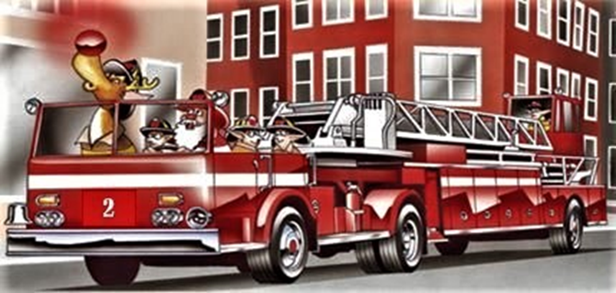

General Order # 1,056 December 2020

Date: Friday December 18th, 2020

Location: Virtual via Google

Time: 2000 hours

Program: President Conway will speak on the Chemical
Apparatus & Equipment of the Lynn Fire
Department.

November Meeting
Our second virtual meeting was held with guest speaker Providence Firefighter Dan Rinaldi providing a program on a MAYDAY situation that he was involved in. 29 members enjoyed the show and asked a number of insightful questions about the incident.

Membership
The Officers and Board of Directors have approved the applications for membership of the following 3 people; Gordon King, William Sullivan and Richard Thomas III. Their applications for membership will be presented and voted upon at the December meeting.

Guest Speaker
Our guest speaker for the evening will be President Rick Conway presenting another segment on the varied history of the Lynn Fire Department. The program will feature the use of Chemical Apparatus from the horse drawn era into the early motorized period. It will also cover chemical equipment carried aboard other apparatus. This is an often, unknown area of fire apparatus and fire department use of the Chemical Wagon.

Line Box
The next issue of the Line Box will be published on or about December 18th. The staff feels that this issue will be one their best yet!

Holiday Wishes
The Board of Directors wishes everyone a happy Holiday season. Here is hoping that 2021 will be better and we will soon be all together again in person!

Reminders
- Virtual Meeting Friday December 18th at 2000 hrs.

- THE TIMES LISTED ARE FOR CENTRAL TIME ZONE AND ARE ONE (1) HOUR BEHIND EASTERN TIME. THE 1900 HOUR START IS ACTUALLY 2000 HOURS!

By Order of the President Newsletter Editor
Richard Conway Frank San Severino

INSTRUCTIONS FOR JOINING GOOGLE MEET

You have been invited to the following event.

Box 52 Assn. Business Meeting
When | Fri Dec 18, 2020 7pm – 9pm Central Time - Chicago
Joining info | Join with Google Meet
 | meet.google.com/dfh-uxqj-dwj
 | Join by phone
 | (US) +1 541-900-5065 (PIN: 464047627)
 | More phone numbers
Calendar | richardaconway@comcast.net
Who | • wally.banks@ifba.org - organizer  • richardaconway@comcast.net

