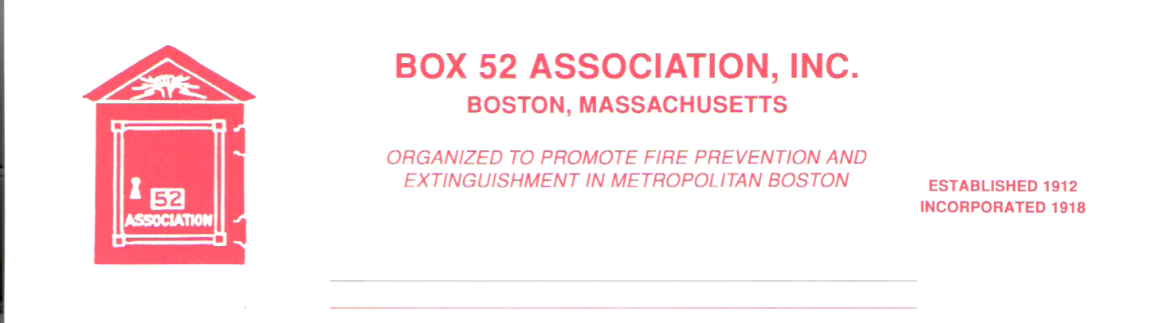
OFFICERS DIRECTORS
PRESIDENT Richard A. Conway Frank Barry
richardaconway@comcast.net Thomas Brophy
VICE James Cullen Michael Kass
PRESIDENT jandm0603@hotmail.com Patrick O’Connor
SECRETARY Jeff Brown David Parr
jeffb0841@gmail.com John Rafferty
TREASURER William H. Wilderman – 617-212-8186
Bwilderman@feinewengland.com
Mailing Address:
Box 52 Association
Website: www.Box52.org c/o William H. Wilderman
E-Mail: box52boston@hotmail.com PO Box 848
Medford, MA. 02155-0009

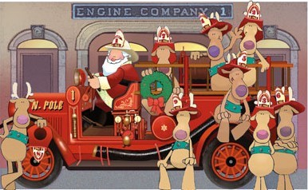

General Order # 1,069 December, 2021

DATE: Friday December 17th, 2021

LOCATION: Wayne Alarm 424 Essex Street Lynn, MA

MEMBERS ARE URGED TO CAR POOL AS PARKING IS LIMITED!

TIME: 1830 Hours our traditional Italian Buffet
2000 Hours Meeting

PROGRAM: Member and Past President Peter Aloisi will present a
Program on North Shore fires. This is our first dinner
meeting since Dec. of 2019! Don’t miss it.

This meeting is for members and applicants only!

November Meeting

Some thirty five members and guests attend the meeting held at the Cambridge American Legion Marsh Post along the banks of the Charles River. President Conway presented a show on the fortieth anniversary of the Lynn Conflagration of November 28th, 1981. The show was enjoyed by one and all.

December Meeting

After a Covid enforced cancellation of our annual Italian Buffet at Wayne Alarm as the guests of honorary member Ralph Sevinor, we return to Lynn. Our entertainment for the evening will be member and Past President Peter Aloisi who will present a program on North Shore fires. The door prize of the customized Hallmark Ornament will be raffled off. This year member Charlie Tentas has done it up to represent Weston Engine 2 the 1966 Ford/Pirsch pump. Please try and make it to this meeting and enjoy a great meal, great comradery and some awesome fire photos and the chance to win a one of a kind Hallmark Fire Brigade series ornament!

Good and Welfare

Condolences to member John McGuire on the passing of his son John III. May his soul rest in peace.

Noted Boston Buff and BFD historian Mr. Elliot Belin has passed away on Monday December 6th.

Line Box
The second issue of this season’s Line Box, also known as the “Trains and Hoses”, issue will be out before the Christmas holiday. Staff is waiting on further information on two of the stories. Not to worry, it will be another great read!

Reminders
- Friday December 17th meeting for member and applicants only. Wayne Alarm 424 Essex Street Lynn. Dinner at 1830 hrs. meeting 2000 hrs. Please try and car pool as parking is limited.

By Order of the President Newsletter Editor
Richard Conway Frank San Severino

