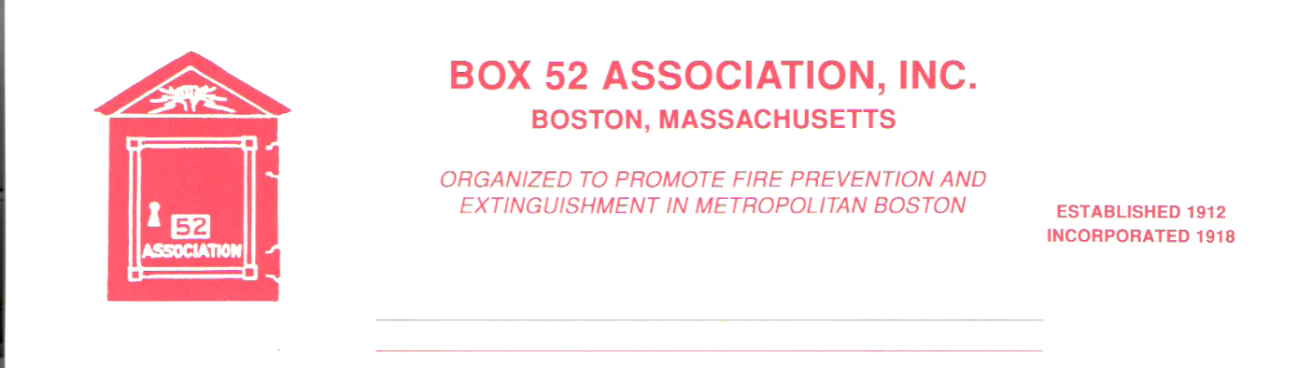
OFFICERS DIRECTORS
PRESIDENT Richard A. Conway Frank Barry
richardaconway@comcast.net Thomas Brophy
VICE James Cullen Michael Kass
PRESIDENT jandm0603@hotmail.com Patrick O’Connor
SECRETARY Jeff Brown David Parr
jeffb0841@gmail.com John Rafferty
TREASURER William H. Wilderman – 617-212-8186
Bwilderman@feinewengland.com
Mailing Address:
Box 52 Association
Website: www.Box52.org c/o William H. Wilderman
E-Mail: box52boston@hotmail.com PO Box 848
Medford, MA. 02155-0009

General Order # 1,055 November 2020

Date: Friday November 20th, 2020

Location: Virtual via Google

Time: 2000 hours

Program: MAYDAY! With Providence, RI. Firefighter
Dan Rinaldi of the Special Hazards.

October Meeting
Twenty-seven members and guests attended our first virtual meeting. All agreed that it went off without a hitch and Member Michael Boynton’s presentation of vintage apparatus from the late Bryon Hurst collection was a treat for all.
This was also the annual business meeting of the Association and with the exception of the Audit Committee, all reports were presented to the Membership. The slate of officers was put before the membership and the Secretary cast one ballot and the following members were elected into office:
President Richard Conway, Vice President James Cullen, Secretary Jeff Brown, Treasurer William Wilderman and 2 directors Dave Parr for his 2nd 3 year term and Pat O’Connor for his 1st.

Guest Speaker
Our guest speaker for the evening will be Providence, Rhode Island Firefighter Dan Rinaldi of the Special Hazards Company. On June 27, 2018, Firefighter Rinaldi was in a MAYDAY situation when he became trapped on the second floor of a burning wood frame dwelling. His story on survival with only minor injuries is not to be missed!

Board of Directors
With member James Cullen elected to Vice President, this left an opening on the Board to finish his term. Past President Frank Barry was appointed to fill the un-expired vacancy until next year’s election.

Membership
The following three applicants were interviewed by the Board at the November Board Meeting and they are listed for their first reading of their applications: Gordon King, William Sullivan and Richard Thomas III.

Good and Welfare
Congratulations to member Len Dunn and to Applicant William Sullivan on their promotions to Assistant Chief and Chief of Department of the Malden Fire Department.

Virtual Meetings
The October meeting was a huge success! It is a great way to attend meetings and interact with your fellow members. Did you know you can even take part via telephone? Just dial in on the numbers listed on the invitation page. Any questions about this, please reach out to President Conway. We hope to see many members logged on for the November Meeting!

Reminders
- Virtual Meeting Friday November 20th at 2000 hrs.

- THE TIMES LISTED ARE FOR CENTRAL TIME ZONE AND ARE ONE (1) HOUR BEHIND EASTERN TIME. THE 1900 HOUR START IS ACTUALLY 2000 HOURS!

The Officers and Board of Directors wish all members a very happy Thanksgiving.

By Order of the President Newsletter Editor
Richard Conway Frank San Severino

INSTRUCTIONS FOR ACCESSING THE VIRTUAL MEETING

When | Fri Nov 20, 2020 7pm – 9pm Central Time - Chicago
Joining info | Join with Google Meet
 | meet.google.com/cos-snug-rai
 | Join by phone
 | (US) +1 413-648-8481 (PIN: 107143201)
 | More phone numbers
Calendar | richardaconway@comcast.net
Who | • wally.banks@ifba.org - organizer

To join the meeting just enter the meet.google.com link above. You should have a camera on your computer, but it is not necessary. You can also call in at the above listed phone number and take part. Just remember to put the above pin code in when prompted to do so.

Proper virtual meeting conduct:
- Keep your mic on mute, unless you need to speak
- Raise your hand to be acknowledge to speak

