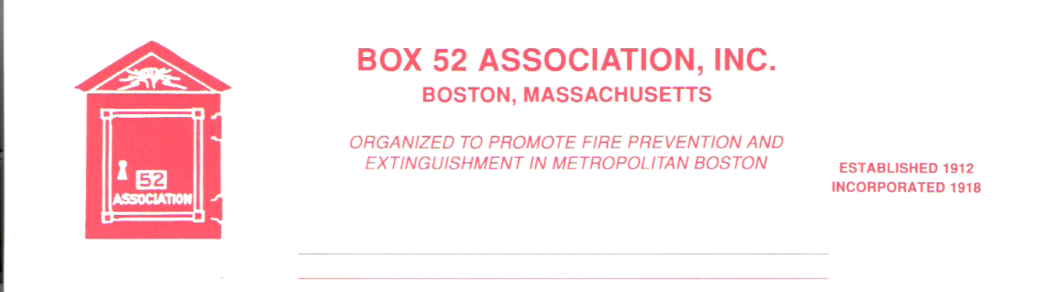
OFFICERS DIRECTORS
PRESIDENT Richard A. Conway Frank Barry
richardaconway@comcast.net Thomas Brophy
VICE James Cullen Michael Kass
PRESIDENT jandm0603@hotmail.com Patrick O’Connor
SECRETARY Jeff Brown David Parr
jeffb0841@gmail.com John Rafferty
TREASURER William H. Wilderman – 617-212-8186
Bwilderman@feinewengland.com
Mailing Address:
Box 52 Association
Website: www.Box52.org c/o William H. Wilderman
E-Mail: box52boston@hotmail.com PO Box 848
Medford, MA. 02155-0009

General Order # 1,068 November, 2021

DATE: Friday, November 19, 2021

LOCATION: American Legion Marsh Post 442
5 Greenough Blvd. Cambridge 02138

TIME: 2000 hours

PROGRAM: President Conway will present a program
On the 40th anniversary of the “2nd Great
Lynn Fire, November 28th, 1981.

Meeting Site
Thanks to an assist by Life Member Gerard Mahoney the Association will be meeting at the Marsh Post in Cambridge (The editor’s father was a life member of this Post). The Post is located at 5 Greenough Blvd. There is a large parking lot at the front of the post.

Guest Speaker
November 28th will be the 40th anniversary of the 2nd Great Lynn Fire. President Conway will present a program covering all aspects of the fire. This should be a very interesting program that all members will enjoy.

October Meeting
The annual meeting was held at the Brookline Training Academy. Box 52 member and Brookline Chief of Operations Keith Flaherty set up the meeting and the speaker was former chief John Spillane, who gave an in-depth history of the Brookline Fire Department from colonial times to the present. 35 members and guests enjoyed the program.

Dues
Please make sure that your dues are paid promptly. Any member having difficulty is asked to contact any Officer for assistance. Dues are $ 35.00 per year.

Election of Officers
The following were voted into officer at the October meeting.
President-Richard Conway
Vice-President-James Cullen
Secretary-Jeff Brown
Treasurer-William H. Wilderman
Director for 1st term-Frank Barry
Director for 2nd term-Tom Brophy

Reminders
- November 19th at 2000 hrs. Marsh Post American Legion Cambridge.
- Pay your dues as soon as possible.

By Order of the President Newsletter Editor
Richard Conway Frank San Severino

