The Line Box
Box 52 Association
Vol. 6 No. 5 May 2010
Staff: Frank San Severino, Mark Roche, John Galla
E-mail: thelinebox@hotmail.com
_______________________________________________________________________

Boston Multiple Alarms March – April 2010
Date Box District Address Building Type
03-05 | 2-3429 | D-8 | 12 Stanton Street | 2.5 story wdfr dwelling
03-13 | 2-12-235 | D-4 | 400 The Fenway | 4 story ordinary office bldg
03-15 | 2-2534 | D-9 | 110 McBride Street | 2.5 story wdfr dwelling
03-23 | 2-3842 | D-12 | 1904 River Street | 1.5 story ordinary apt bldg
04-05 | 2-1433 | D-4 | 11-11A Hudson Street | 4 story brick taxpayer
04-07 | 9-1583 | D-4 | 483 Beacon Street | 10 story brick high rise apartment
04-16 | 3-354 | D-8 | 911 Morton Street | 3 story wdfr
04-20 | 2-2374 | D-3 | 0 Charles St @ Boston Common | SUV on fire 3rd level Boston Common Garage
04-29 | 3-33-1442 | D-3 | 426 Washington Street  Downtown Crossing MBTA Station | Fire in Red Line tunnel 600 volt cable arcing and burning

Not much new to report since the last issue for BFD and Metro-Fire. Time lines for the 9-‘bagga’ and the Red Line Fire, both provided by Mr. Elliot Belin.

Box 1583 483 Beacon Street
1347 Box 1583
E-22, E-37, E-3 L-15, L-26 R-1 D-4 , C-6
1352 Rapid Intervention Team (RIT) assigned by Fire Alarm
E-39*, L-4*, D-11
1352 Rehab unit assigned by Fire Alarm
W-25
1358 2-1583 Orders of C-6
E-33, E-14, TL-3, W-12, Spec. Unit, FIC, W-12, Z-1, A-65
1359 3-1583 Orders of C-6
E-24, E-42, L-14, X-1
1402 4-1583 Orders of C-6
E-51, E-53
1404 Spec. Call by C-6 extra engine and 2 extra ladders
E-7, L-24, L-16 (RIT)
1407 5-1583 Orders of C-6
E-21, E55, TL-10, C-1, C-2, C-3
Brookline E-1 to E-28, Cambridge E-2 to E-33, Quincy E-2 to E-18,
Brookline L-2 to L-14, Quincy L-2 to L-7
1413 6-1583 Orders of C-6
E-50, E-16
Needham E-1 to E-30, Newton E-1 to E-51, Somerville E-2 to E-32
1415 7-1583 Orders of C-6
E-28, E-8, TL-17
Chelsea E-2 to E-9, Dedham E-1 to E-48, Winthrop E-1 to E-10, Cambridge L-1 to L-15

1421 Spec, Call by C-2 Hi-Angle Rescue
E-10 with H-4
1421 8-1583 Orders of C-2
E-18, E-56, L-18
Everett E-1 to E-8, Milton E-1 to E-16, Watertown E-1 to E-27
1434 9-1583 Orders of C-2
E-32, E-30, E-4
Revere E-3 to E-5, Waltham E-2 to E-41
Additional Mutual Aid: Malden E-3 to E-6, Cambridge E-3 to E-4, Somerville L-2 to L-24
1601 Fire Detail: 2 engines and 2 ladders by C-6
E-20, E-52, L-1, L-6
1925 All out 1583

Box 33-1442 426 Washington Street Downtown Crossing Red & Orange Lines Station

2158 Box 33-1442
E-10, E-4, E-7, L-24, Tl-17, R-2, Special Unit, FIC, D-3, D-4, C-6
2158 Rapid Intervention Team (RIT) assigned by Fire Alarm
E-50, D-1
2200 Rehab unit assigned by Fire Alarm:
W-25
2209 2-33-1442 Orders of C-6
E-3, E-39, E-21, E-22 L-15, L-18, W-12, Z-1, A-65
2209 3-33-1442 Orders of C-6
E-18, E-14, L-26, X-1
2241 Special Call by D-1 (RIT) extra engine and ladder
D-51, L-4

JORDAN’S MEAT PLANT
On Thursday May 6th a fast moving 3-alarm fire destroyed the former Jordan’s Meat Plant on India Street Portland Maine. The plant was being razed at the time of the fire. Here is a link with photos, video and audio of the fire: http://www.portlandfirefighters.com/jordan_meats_may_2010.htm

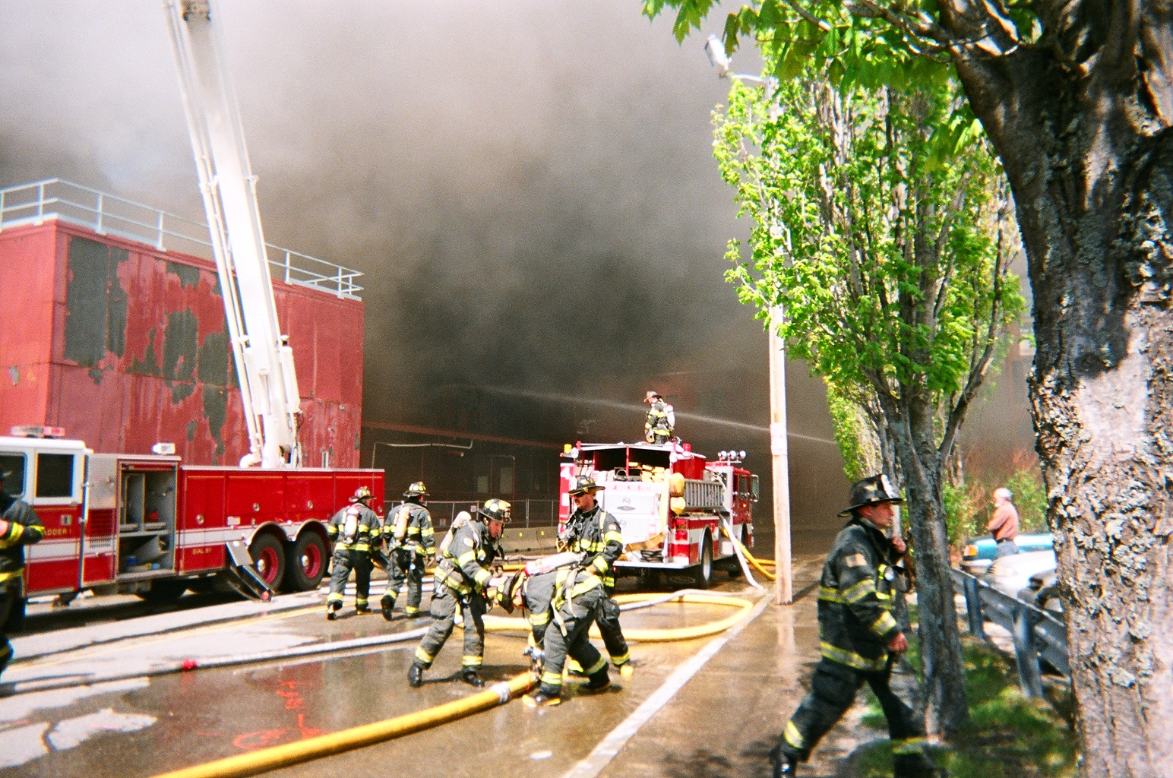
Portland Jakes go to work on Jordan’s. Photo courtesy IAFF Local 740 Portland FFs

F.D.N.Y
A true old school Manhattan job occurred on April 7th, 2010. Fire was in the China Town, here is the breakdown of the response:

Box 259 @ 2214 285 Grant St. between: Forsyth St. & Eldridge St.
Eng. 9, 55, 15 Lad. 6, T. Lad. 18 Batt. 4
22:19 1075 – 259
Ladder 20 “FAST” Trucks
Eng. 28, Rescue 1, Squad 18 Batt. 2, Division 1
Fire Building:
6 Story Brick 60 x 75 Comm. / M.D.
Exp. #1: Is a Street
Exp. #2: Is a Similar Type attach
Exp. #3: Is Unknown
Exp. #4: Is a Similar Type attach
22; 21 Batt. 4 reports: Box 259, Truck Co’s are “Opening Up” trying to locate the source of the smoke. Not sure if this is the right Bldg. We have 1line stretched and standing by.
22:25 Division 1: Change the address to 285 Grant St. (Orig. Was 283)
We have heavy smoke thru out the Bldg. Still trying to locate the source of the fire. We have 1 line stretched at this time.
22:25 Special Call: Additional Engine & Truck.
Engine 7 Ladders 11
22; 29 Division 1 reports: “At Box 259, we have a 6 Story Brick, Commercial on the 1st floor with a multiple dwelling on the floors above. Heavy smoke condition, Trucks are “Opening Up” and still searching for the fire. Fire is Doubtful.”
22:31 Car 6: Assist. Chief Esposito on scene
22:34 “Car 6 to Manhattan, Transmit a 2nd Alarm. We have a heavy smoke condition in the cellar and 1st floor. Undetermined where the source of the fire is at this time. Trucks are still “Opening Up”
2 – 2 – 259 Engs. 33, 5, 6, 10 T. Lad. 9, Lad. 3 act 6
Eng. 24 w/ Satellite 1
Batt. 1 “Safety Officer”
Batt. 6 “Resource Unit Leader”
Rescue Battalion / Safety Battalion
Field Com 1 / Tactical Support Unit #1
Command Tactical Unit
Rac. #1
22:36 Car 6: Box 259, we have (1) 10-45 No Code
22:38 Car 6: Special Call an additional Truck.
Tower Ladder 1
22:42Car 6: Special Call another additional Truck.
Ladder 8
22:43 Car 6: We have a 2nd 10-45 No Code, Total of (2)
22:48 “Car 6 to Manhattan, by order’s of Assist. Chief Esposito, Transmit a full 3rd Alarm”
3 – 3 – 259 Engs. 4, 3, 16, 23 act. 55 Lads. 10, 5
Batt. 7
Batt. 35 “Staging Manager”
Batt. 43 “Air Recon Chief”
Mask Service Unit #1
Staging Area: Grant St. & Christie St.
22:55 Car 6: Special Call (2) additional Trucks.
Tower Ladder 21 act 1, Tower Ladder 15
23:00 Car 6: Special Call (2) additional Battalion Chiefs
Batt 8 Batt. 31
23:01 “Car 6 to Manhattan, by order’s of Assist. Chief Esposito, Transmit a 4th Alarm”
4 – 4 – 259 Engs. 8, 1, 54, 14 T. Lad. 7, T. Lad. 12
Batt. 57 “Planning Chief”
Eng. 262 w/ I.M.V. (Incident Management Vehicle)
Car 4: “Chief of Operations”
23:08 Manhattan in “Fall Back Step 3” Limited Response to all alarms

23:10 Field Com 1: Progress Report for the 4th Alarm, Box 259, and Car 6, Assist. Chief Esposito reports: Heavy fire in the basement with extensions to the 1st floor of 283 Grant St. Extensions to Exp. #2 into the 1st floor of 285 Grant St. (5) Hand-lines stretched and in operation. Evacuations of all civilians from the upper floors of both Bldgs. Getting water on the fire. Primary Searches are in progress. Fire is doubtful will hold.
23:15 Field Com 1: Special Call (2) additional Battalion Chiefs
Batt. 9, Batt. 32 act. 1
23:18 Field Com 1: By orders of Car 6, Assist. Chief James Esposito, Transmit the 5th Alarm.
5 – 5 – 259 Engs. 26, 230 act. 10, 226, 34 act. 24
Car 3: Chief of Department
Car 1: Fire Commissioner
23:23 Field Com 1: By orders of Car 6, Assist. Chief James Esposito, Transmit the 6th Alarm.
6-6-259 Ends: 54, 205, 224, 210, 211, Lad. 24
23:26 Field Com 1: Progress Report for the 4th Alarm, Box 259, and Car 6, Assist. Chief Esposito reports: (8) hand-lines stretched and in operation. Fire 1st & 2nd floors of Exp. #2. Fire has extended up thru the 3rd floor of the original Fire Bldg. We have (2) additional 10-45’s. A total of (4) No Codes at this time. Continuing to evacuate civilians from the upper floors. Fire remains Doubtful Will Hold.
23:34 Field Com 1: Special Call a 95 ft. Tower Ladder.
Tower Ladder 14 act. 21
23:42 Field Com 1: Car 4, Assist. Chief Sweeney reports: Pulling all members out of the Badges. Roll Call is being conducted.
23:44 Batt 43: “Air Re – Con Chief” reporting heavy fire thru the roof of the Fire Bldg.
23:55 Field Com 1: Special Call an additional “FAST” Truck to report in on the Exp. #3 side.
Ladder 118 s/c additional “FAST” Truck
23:56 Field Com 1: By orders of Car 3, Chief of Department
Special Call (2) additional Engines. (Originally asked for 7th Alarm, but changed to (2) add. Engs. )
Eng. 21 act 15, Eng. 219
24:00 Field Com 1: Progress Report for the 6th Alarm, Box 259, Car 3, Chief of Department reports: Have heavy fire all floors & thru roof of original Fire Bldg Heavy fire all floors of Exp. #2. (2) Tower Ladders set up & operating on Fire Bldg. And Exp. #2. We have extension to Exp. #2A. (2) Hand-lines in operation in Exp. #2A. Fire is Doubtful.
00:05 Field Com 1: By orders of the Chief of Department, Transmit a 7th Alarm.
7-7-295 Engs. 216, 258 act 33, 271 act. 6, 202 Lad. 30 act. 3, T. Lad. 146 act. 18
00:07 Field Com 1: Special Call an additional Division Chief.
Division 11
00:34 Field Cm 1: Special Call an additional Battalion Chief
Batt. 44
00:46 Field Com 1: Progress Report for the 7th Alarm, Box 259, Car 3, Chief of Department reports: Fire Exp. #2A on the 4th; 5th; 6th; floors and Cockloft. (1) Tower Ladder operating on the original Fire Bldg. (1) Tower Ladder operating on Exp. #2 & 2A. Had fire extension into Exp. #4. This fire has been knocked down.
00:54 Field Com 1: The original 10-45’s reported: (2) are Code 2’s, (2) are Code 4’s
01:35 Field Com 1: Progress Report for the 7th Alarm, Box 259, Car 3, Chief of Department reports: At this time, Have shut down all Tower Ladders. No visible fire showing in the original Fire Bldg; Exp. #2 & Exp. #2A. Evaluating the structure stability of the original Fire Bldg. & Exp. #2. Going back to hand-line operations in Exp. #2A. Fire is Probably Will Hold.
02:12 Field Com 1: Progress Report for the 7th Alarm, Box 259, Car 3, Chief of Department reports: (1) Tower Ladder operating in Exp. #2. (2) Hand-lines operating in Exp. #2A knocking down remaining pockets of fire in the shaft & Cockloft. Chief Kilduff place’s this Fire Under Control.

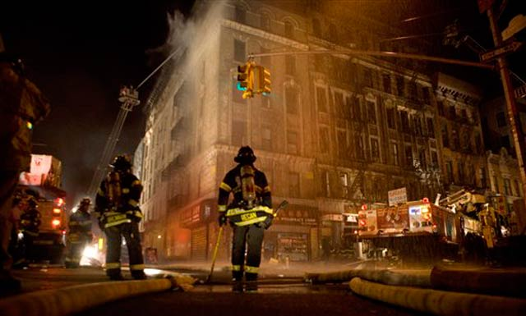
Chinatown seven bagga. Photo D. Goldman AP photo

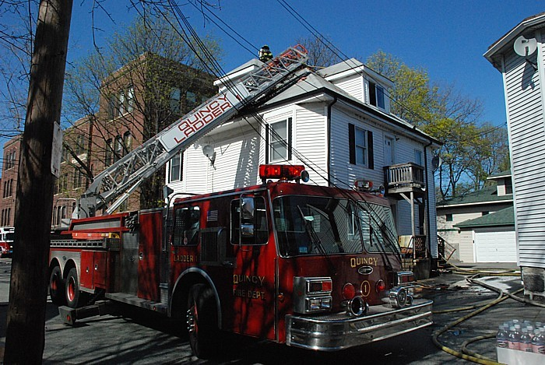
The troops in Quincy made short work of this All-Hands at 52 Phipps Street on 5/6/10.
Photo by member M. Worley

M.W.R.A Water Emergency in Quincy

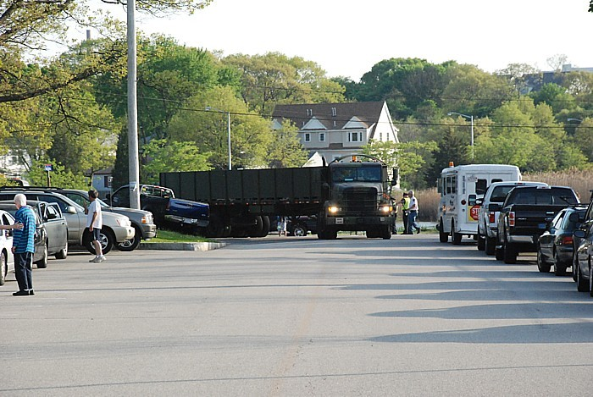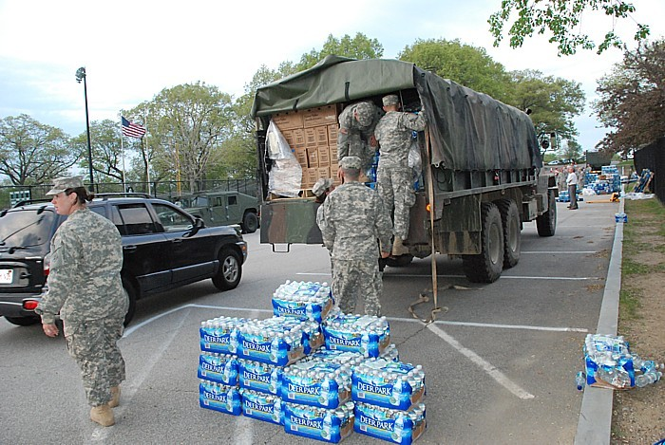
National Guard and Quincy officials set up a water distribution site during the MWRA water emergency.
Photos by member M. Worley

.

