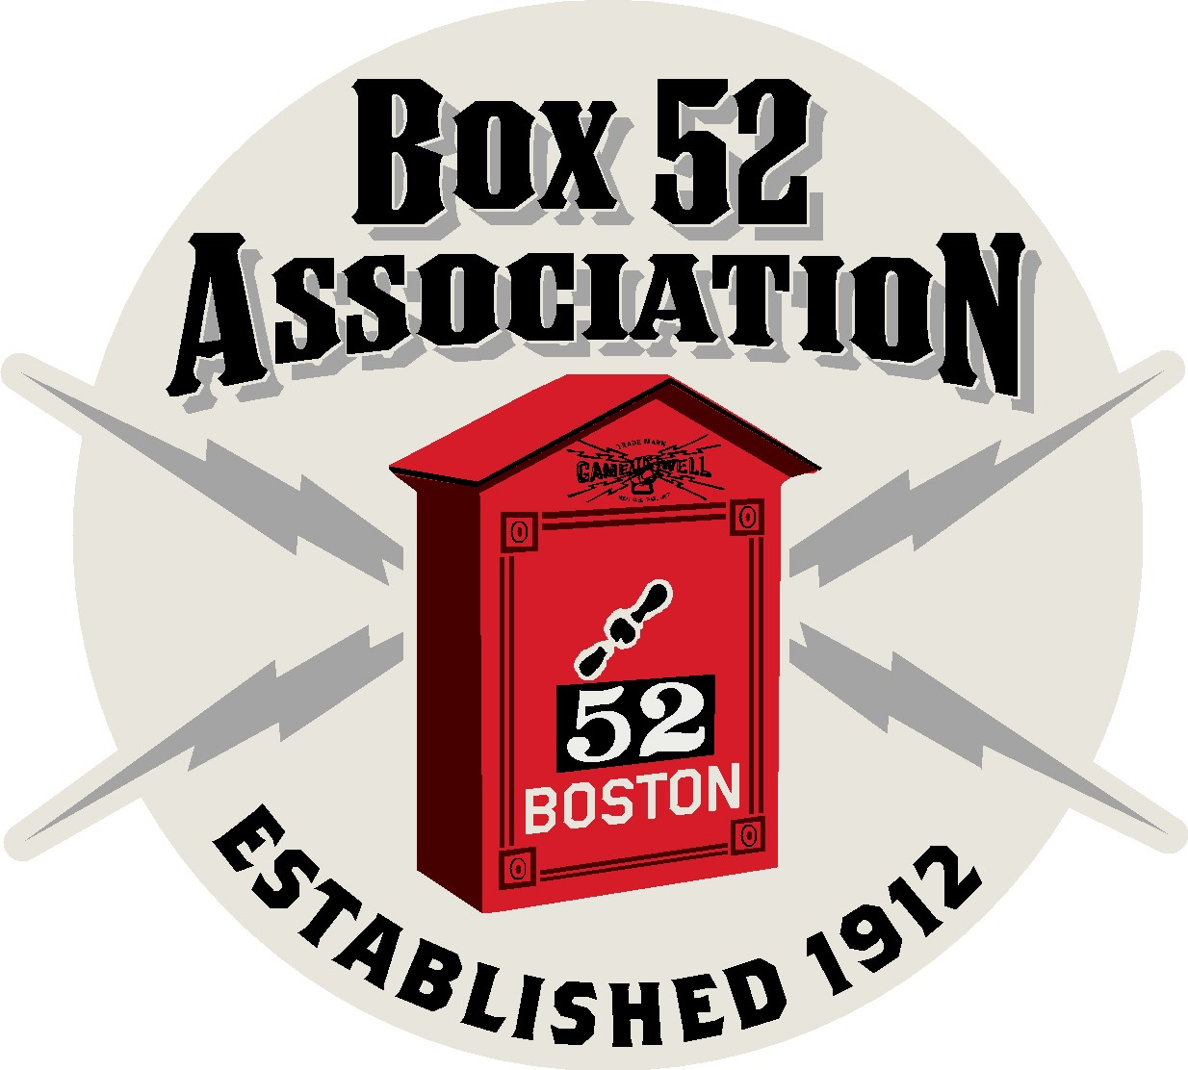 | The Line Box
 | Volume 7, Number 2
In This Issue  - Boston Multiples  - Boston News  - Metro-Fire News  - News Tid Bits  - Great Boston Fire  Editors  Frank San Severino  Mark Roche  John Galla  Contact Us  http://www.box52.org  thelinebox@hotmail.com | Welcome to the new look for the Line Box!  Boston Multiple Alarms September – October 2010  Date Box District Address Building Type  B.F.D News  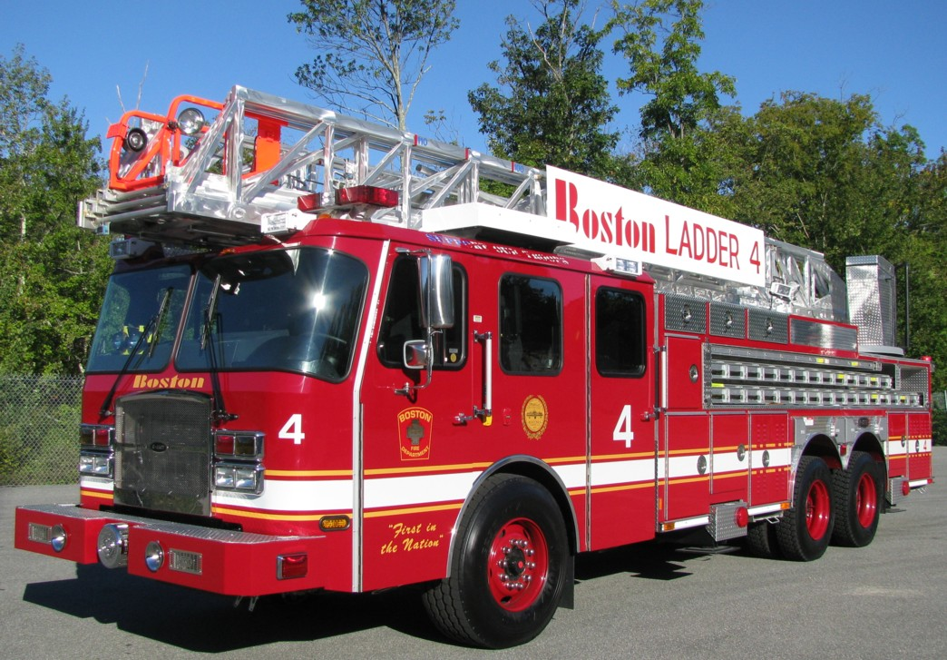  Photo by MEB  Ladder Companies 4 and 15 have placed in service 2010 Emergency-One rear mounts. These are identical to the two units delivered earlier this year to Ladders 6 & 24.  MARINE 3 “Captain John F. Kenney” was placed in service at Burroughs Wharf. The 2010 30 foot Ribcraft 9.0 Dive Boat, it is powered by twin 225 horsepower Evinrude outboard engines and can reach speeds of 50 mph! The craft was designed by members of the BFD Dive Team. The boat was in-service less than 3 hours when it responded to a fire on the Northern Ave. bridge.  Bids have been requested to fully re-hab and update three E-One pumps. Another bid is for two additional ladder trucks.  METRO-FIRE NEWS  Lynn has just changed over and call sign KCC 866 is gone!  Here is the channel assignments  Ch. 1 470.1750 PL 88.5 Dispatch for Lynn, Nahant & Swampscott  Ch. 2 482.1625 PL 79.7 Lynn Fire Ground  Ch. 3 482.8500 DPL D-125 Fire Ground for Nahant & Swampscott and Nahant paging  Ch. 4 473.1750 PL 88.5 Direct mode for channel 1  Newton has closed station 7 144 Elliot Street for a complete renovation of the 1955 fire house. Companies have been located to other quarters. E-7 has moved to a temporary station at 44 Elliot Street while L-2 has re-located to station 2.  Everett has placed Ladder 1 back in-service after a lengthy re-furb at Minute Man Truck.  Malden has taken delivery of a 2010 Pierce Arrow pump for Engine 3. The apparatus is rated at 1500 GPM and has a 750 gallon tank.  Weymouth has placed a new E-One Typhoon pump in-service for Engine 5. This new kit has a 1500 GPM pump, 750 gallon tank with 30 gallons of foam.  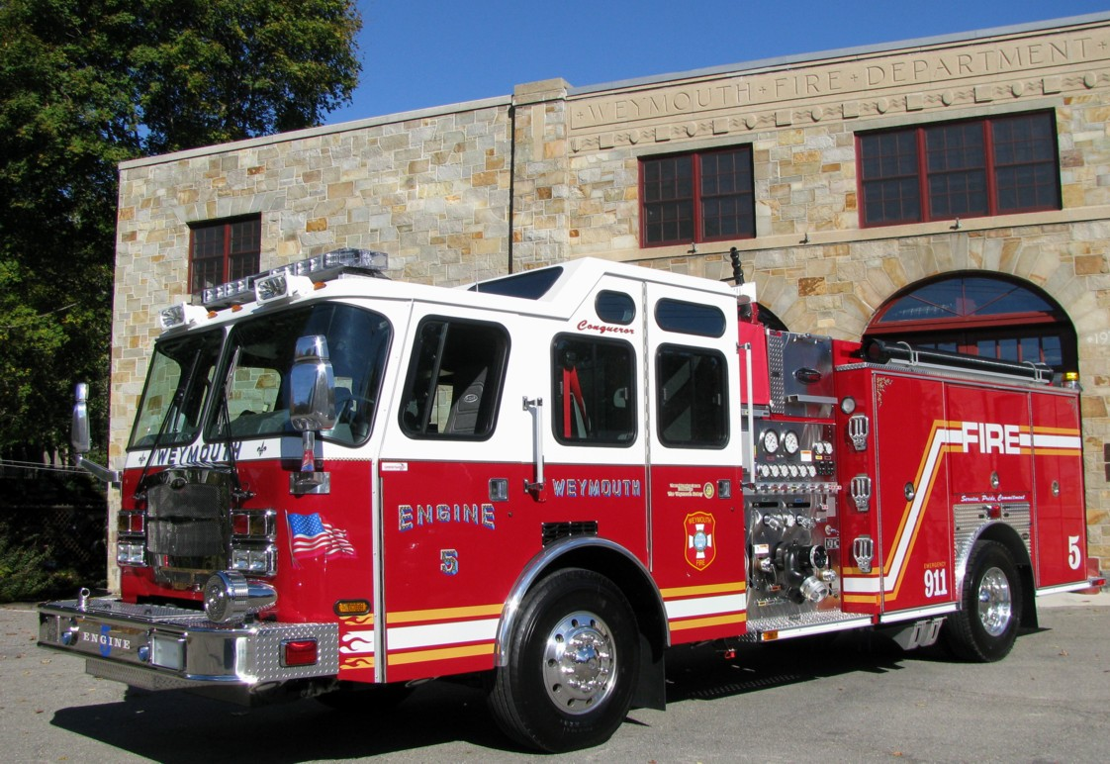  Weymouth E-5, Photo by MEB  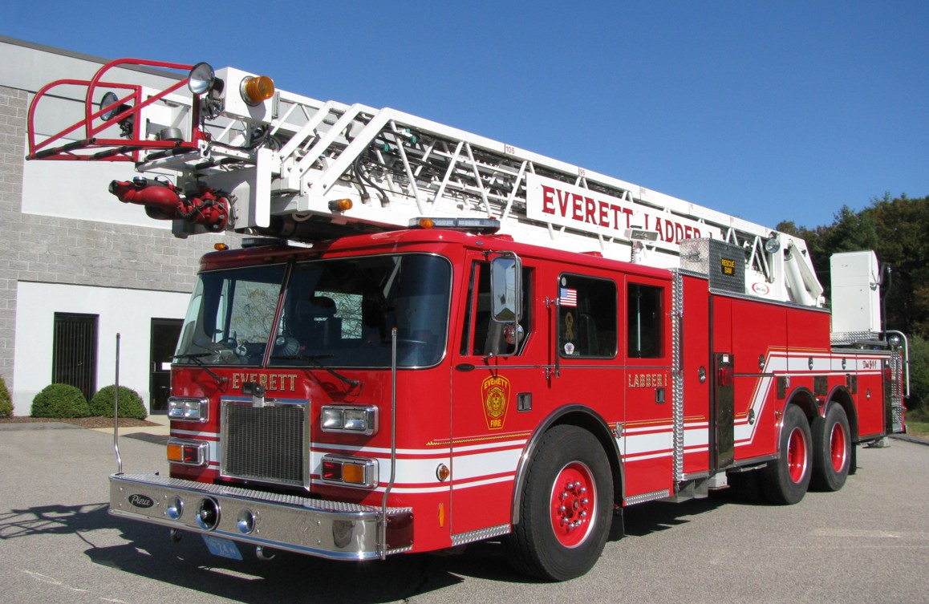  Everett Ladder 1 gleams in the sun for its photo. Photo by MEB  NEWS TID BITS  Member Peter Aloisi has penned a new tome titled FIRE BUFFS. It is available direct from Peter’s website www.chariotpublishing.net  MATCHBOX TOYS FOR FIRE BUFFS  For those Members who collect Match box size emergency vehicles….this is your year! M-Box has released a Pierce Dash pump, IH Work Star Brush unit (Calf class 3 model pump), 1963 Caddy Ambulance and my favorite a Haz-mat squad! In the Real Working Rigs line is a Pierce Quantum RMA in various colors, the other release is a Colet ARFF unit.  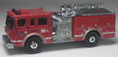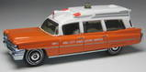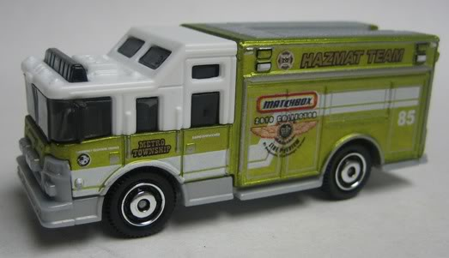  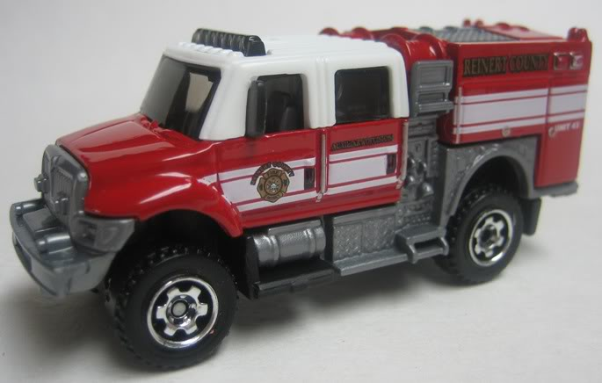 All photos courtesy of Mbox collectors.com  GREAT BOSTON FIRE 1872  William Blaney, a sober and systematic man was in charge of the boiler in the basement of a five story granite building at the corner of Summer and Kingston Streets. He tended the boiler, which was showing 10 pounds of steam, with a low fire. He made sure that all grates and doors were closed. He left at 5:20 PM assured that all was in order.  Saturday November 9th 1872 was a cloudless mild Indian summer evening with a glorious moon. By 6:00 PM the entire wholesale district was deserted. The main shopping area along Washington Street was bustling with people. A glow was visible through the basement windows from the Tebbetts, Davis & Baldwin Building, the very building that Blaney had left some forty minutes earlier.  John S. Holmes, a Boston lawyer chatting with a friend on Washington Street at Summer Street, saw smoke and ran towards it, shouting “Fire”. It appeared to Holmes that a fiery globe was burning in the Kingston Street end of the basement while thick smoke poured from the third floor.  Daniel Marden, foreman of Engine 7 the T.C. Amory started his Company before the alarm. A passerby had rung the station bell and reported a fire on Bedford Street. As he arrived his men had recruited the crowd to push the steamer and hose carriage into South Street, where they immediately set to work, as of yet no alarm had been sounded.  Boston Patrolman John M. Page of Station 4 heard yelling and ran after what he thought was a group of boys. As he turned the corner of Summer and Bedford Streets. He was shocked to see fire streaming from a building that he could not see. He was standing beside Box 52, he unlocked the door and sounded the alarm. Page remembering his orders issued a week before by the Fire Department for building fires during the Epizootic, “Any building fire with fire above the third floor, then a second alarm shall be sounded”. Page sounded the second alarm from Box 52.  Above City Hall, in the Fire Alarm Office the box started to tap out. The operator looked out the window and saw flames. Box 52 was relayed to the stations at 7:24 PM November 9th, 1872.  The request for assistance went out of telegraph at 8:00 PM. Chief Damrell was requesting all the aid available be sent to Boston at once. Special Trains, who had clearance over all other trains on the line, highballed to Boston with fire apparatus of flat cars and men riding in coaches. These trains brought aid from Biddeford, Maine, Portsmouth and Manchester, New Hampshire, Worcester, New Bedford, Fall River. From the south came apparatus from Providence, Rhode Island, New Haven and Norwich Conn.  Local communities had all ready dispatched apparatus. The first to arrive was Cambridge Engine Co. 3, the Niagara at 8:15 PM. And the last was New Haven, CT. Engine 2 the H.M. Welch which arrived just before mid-night. Wakefield Firefighters had dragged their hand tub some 12 miles to Boston. Other companies arrived on scene from Charlestown, Somerville, Brookline, Medford, Malden, Watertown, Newton, West Roxbury, Hyde Park, Waltham, Salem, Lynn, Reading, Lawrence, Charlestown Navy Yard, Watertown Arsenal, Haverhill and Tauton. Mutual Aid for the fire was 45 steam engines, 4 hand tubs, and 52 hose companies.  Thirteen persons were killed including Captain William Farry and Lt. Daniel Cochran both of Ladder Company 4. In addition two Cambridge Firefighters were killed. The body of Cambridge Firefighter William Frazier of Hook & Ladder 1 was never recovered. 776 buildings destroyed, property loss of seventy five million dollars.
  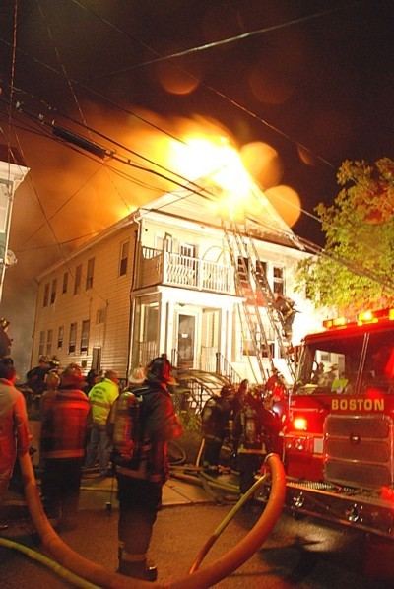  Photo by M. Worley | After spending the summer months learning this new layout of the Line Box, your editors are happy to present it to the membership.  We hope that you all like it and as always, we are looking for photos and information for inclusion in these pages.
  9/09 | 2-373 | D-12 | 111-113 Pierce St | 3 story wood frame
  9/19 | 2-1772 | D-7 | 385 Columbia Road | 2.5 story wood frame
  10/04 | 2-5238 | D-11 | 100-102 Empire Street | 2.5 story wood frame
  10/07 | 2-1845 | D-7 | 110-114 Saxon Street | 3 story wood frame
  10/09 | 2-6153 | D-1 | 16-18 Chelsea Street | 3 story wood frame
  10/13 | 2-3641 | D-8 | 116 Hazleton Street | 2.5 story wood frame
  10/18 | 3-7261 | D-6 | 96-98 Boston Street | 3 story wood frame, mercantile 1st floor
  10/24 | 4-5125 | D-11 | 110 Chester Street | 3 story wood frame

