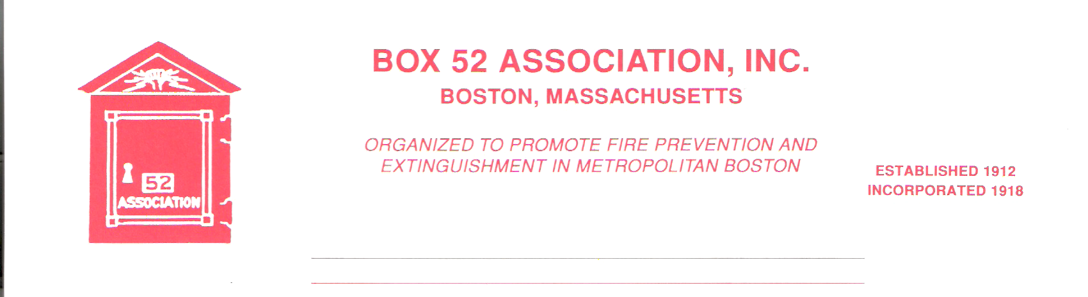
OFFICERS DIRECTORS
PRESIDENT David Parr Jeff Brown
Dave.parr@verizon.net Robert Fitz Jr.
VICE Thomas Brophy Frank Barry
PRESIDENT thomasbrophy25@comcast.net Benjamin Marra
SECRETARY Michael Kass Anthony Scrima
michaelkass@rcn.com Robert Wilker
TREASURER William H. Wilderman – 617-212-8186
Bwilderman@firefire.com
Mailing Box 52 Association
Website: www.Box52.org Address: c/o William H. Wilderman E-Mail: thelinebox@hotmail.com PO Box 848
Medford, Ma. 02155-0009

General Order # 1,027 April, 2017

April 2017 Meeting

DATE: Friday, April 21st, 2017

LOCATION: Annual Visitation – Salem FD Headquarters
48 Lafayette St. @ New Derby St.

TIME: Apparatus Display 1830 – 2000 Hrs.
Sandwiches, chowder and deserts will be served
1830-2000 Hrs.
Meeting 2000 Hrs.

PROGRAM: “Witches and Fires” – History of the Salem Fire
Dept., the City and the Great Salem Fire of June
1914. Presented by Members Thomas Brophy, Jeff
Brown and Nelson Dionne

March Meeting
Member Bill Noonan had prepared a show for us, but due to technical difficulties with the Power Point projector, he was placed out-of-service and Member Kevin Mochen (C7 acting K7) was placed in-service and told several stories of the BFD. The evening was enjoyed by forty members and guests.

April Meeting Parking
The Board is encouraging members to carpool to the Salem Meeting. Public parking is available at the rear of the Salem HQ, enter from New Derby St. and in the downtown area.

Guest Speakers
Our speakers are all natives of the Witch City and students of the rich history of Salem and its fires and Fire Department. Members Brophy, Brown and Dionne will be presenting a most entertaining program.

Membership
Applicant James Nolan will be voted on at the April meeting. Applicant Brian Harrington’s name will be read at the April meeting for final vote into membership at the September 2017 Meeting.

Good & Welfare
Condolences are extended to the following members on loss of family members.
Michael Antoine loss of his father, John Rafferty on the loss of his mother and Wayne Perkins on the loss of his father. May their souls rest in eternal peace.
Get well wishes are extended to members Carl King, mending after a fall and Tony Scrima on the rebound after a cardiac ‘tune-up’.
Congratulations to member Rick Conway on his retirement from the Nashua, N.H. Fire Department.

Bus Trip
The bus trip on Saturday May 13th is filling up fast! Get your seat now! Tickets are $ 35.00 and will include morning coffee, lunch and an afternoon snack. The bus will be leaving from Lexington. Please note that we will be on the tightest schedule of any trip we have ever run. The Committee has made the scouting run and we have met with all the area Chiefs and all are looking forward to seeing us and showing off their Departments!

Coming Events

April 15 – NE Fools Annual Fire Buff Photo Night Sheraton Four Points Hotel Wakefield. Tickets are $ 25.00 and available at the door. Social Hour 1700-1900 – Show starts at 1900 hrs.

May 9 – Essex County Fire Wardens Meeting at Wakefield Public Safety Building at 7:30 PM – Slides of North Shore Fires and Apparatus from the L. Murray Young collection – BOX 52 MEMBERS CORDIALLY INVITED TO ATTEND.

May 12 – Bare Cove Fire Museum – Firehouse Night – 6:30 PM – featuring Cambridge Acting Chief Gerry Mahoney and Doug Boudrow - Tickets are $ 20 at the door

June 10 – MAFAA – Parade & Muster – Lynnfield / Wakefield MA – 10:00 AM

The next issue of the Line Box will feature full listing of musters and parades for the upcoming summer season.

Bus Trip Teasers

Here is just a sampling of the apparatus you see on the Bus Trip. The Committee has planned several surprises in how many and what kind of apparatus will be presented for your enjoyment. And by the way the Committee laid out a possible plan for our 2019 trip! All Photos by Member Michael Boynton.

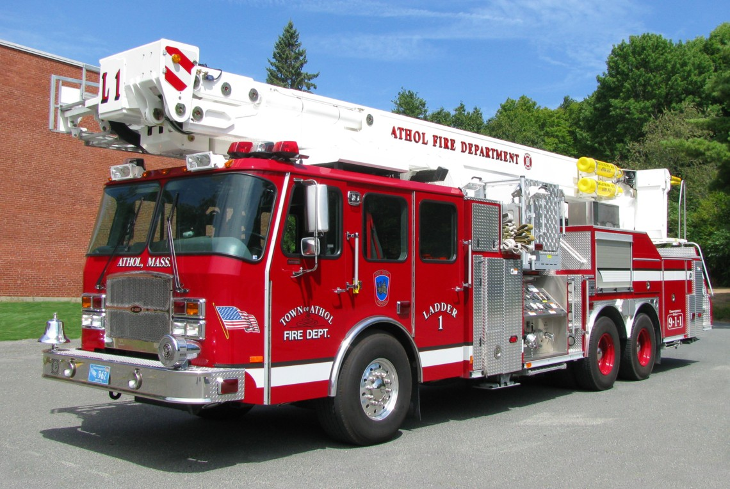

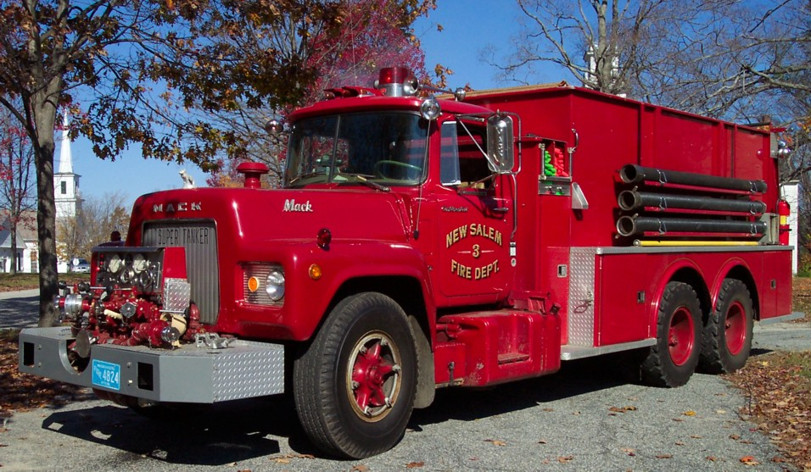

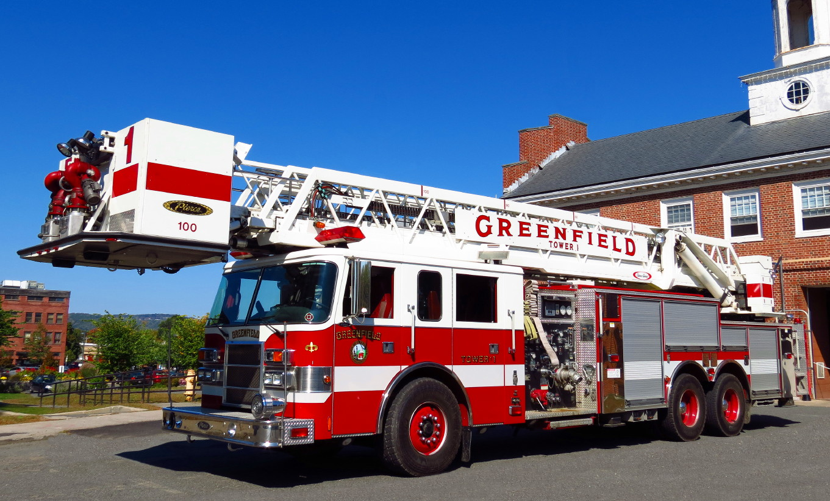

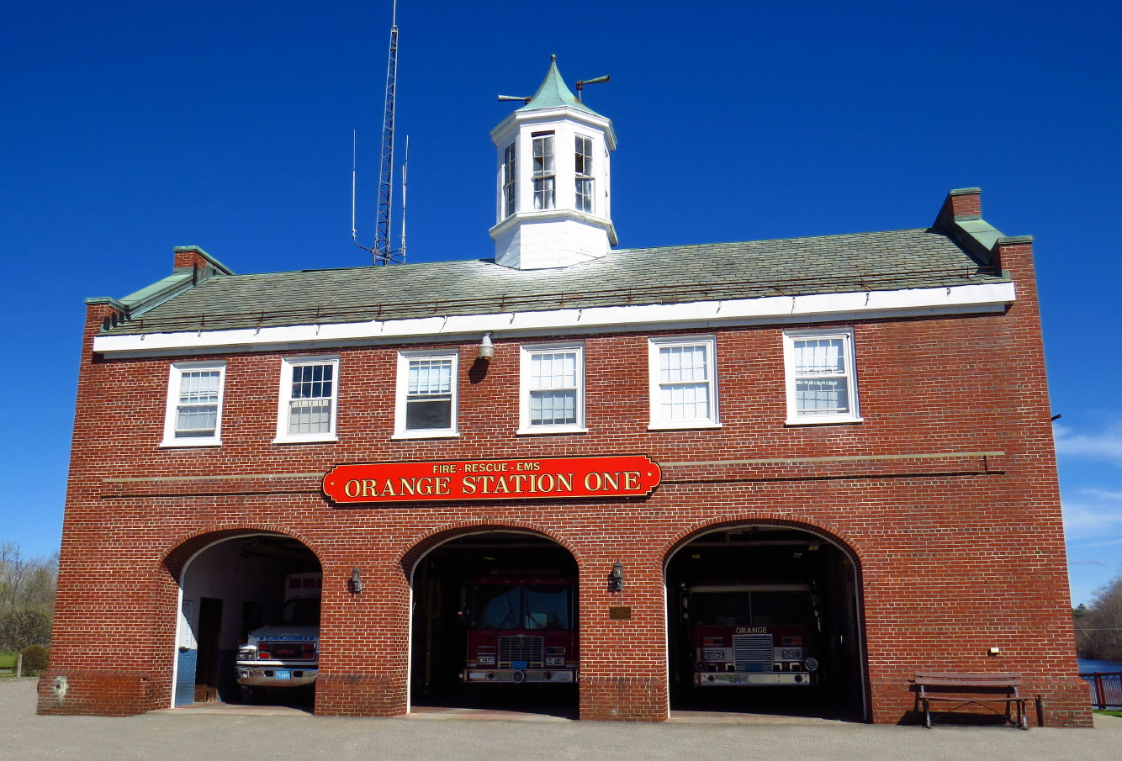

REMINDERS

April 21st meeting at Salem HQ. Carpooling is encouraged
1830-2000 Apparatus display and collation, 2000 Meeting

Be sure you get your seat for the May 13th Bus Trip!!!!!!!!!!!

By Order of the President Newsletter Editor
David Parr Frank San Severino

