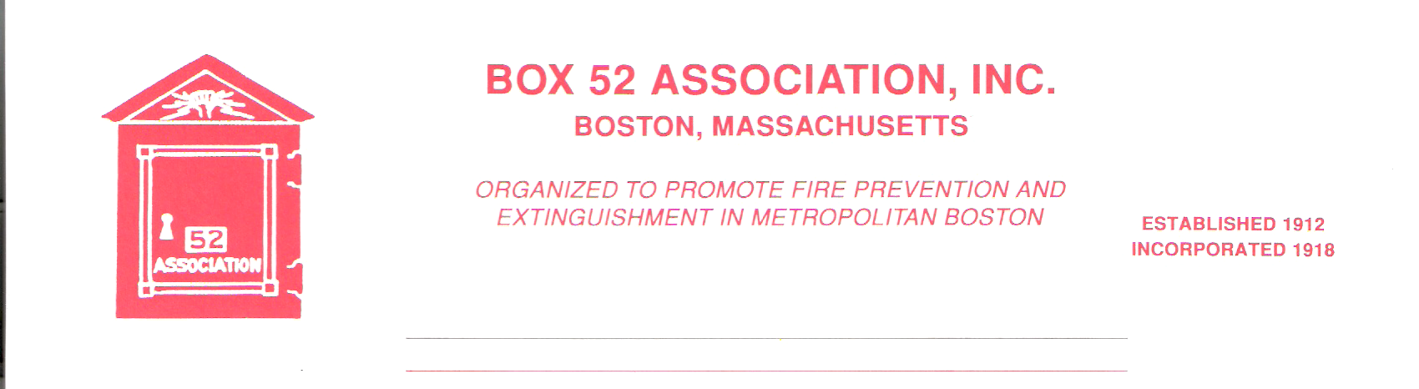
OFFICERS DIRECTORS
PRESIDENT David Parr Jeff Brown
Dave.parr@verizon.net Robert Fitz Jr.
VICE Thomas Brophy Frank Barry
PRESIDENT thomasbrophy25@comcast.net Benjamin Marra
SECRETARY Michael Kass Anthony Scrima
michaelkass@rcn.com Robert Wilker
TREASURER William H. Wilderman – 617-212-8186
Bwilderman@firefire.com
Mailing Box 52 Association
Website: www.Box52.org Address: c/o William H. Wilderman E-Mail: thelinebox@hotmail.com PO Box 848
Medford, Ma. 02155-0009

General Order # 1,023 December, 2016

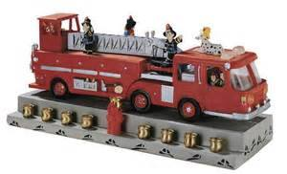

December 2016 Meeting

DATE: Friday, December 16th, 2016
LOCATION: Wayne Alarm 424 Essex Street Lynn, MA

MEMBERS ARE URGED TO CAR POOL PARLING IS LIMITED!

TIME: 1830 Hours Italian Buffet
2000 Hours Meeting

PROGRAM: A presentation of Lynn fires and apparatus, presented by
Member Rick Conway.

This meeting is for members and applicants only!

December Meeting
Our annual December meeting will be hosted by Honorary Member Ralph Sevinor at Wayne Alarm. This year we will have an Italian Buffet. Please remember that the meeting starts 2000 hrs and dinner will be served at 1830 hours. Plan to attend our Holiday meeting and enjoy good food, good friends, and a great show on the Lynn F.D!

Guest Speaker
Once again, Member Rick Conway will be digging into his vast collection of Lynn fires and apparatus for another great show.

November Meeting
Members and guests were treated to a great show on Boston’s famed ladder culture, presented by BFD Lt. Shawn Donovan of Ladder Company 4.

Good and Welfare
Once again, we are saddened to report that member Steve Walsh has had yet another setback in his recovery and is hospitalized at the Brigham & Women’s Hospital.

Member Tom Tully was published in the Lynnfield Villager newspaper about his service with the Navy during the Vietnam Conflict. Thank you to Tom and all our Vets for your service to our Country. Please check out the article on our website www.box52.org.

Membership
Members William Noonan and Richard Somerville have both accepted the offer of Life Membership. Mr. Noonan was elected into membership on October 20, 1978 and Mr. Somerville on November 9, 1978.

The application of Mr. James McGonagle will be read at the December meeting and will be voted on at the January 2017 meeting.

Weather Cancellation
It’s that time of year again, the leaves have fallen, the days are shorter, and soon the first snow fall will occur, fouling up the meeting nights! The meeting cancellation will be broadcast over Citywide Radio, Facebook, along with e-mails being sent out. After all it is winter in New England! Let’s all hope it’s an easy winter like last year!

Line Box
The year’s second installment of the Line Box is being issued this month, it is the largest we have ever produced and the staff is sure that you will enjoy it!

Seasons Greetings
The Officers and Board of Directors wish all Members a very happy and joyous Holiday Season and best wishes to each of you and your families for a peaceful and prosperous 2017!

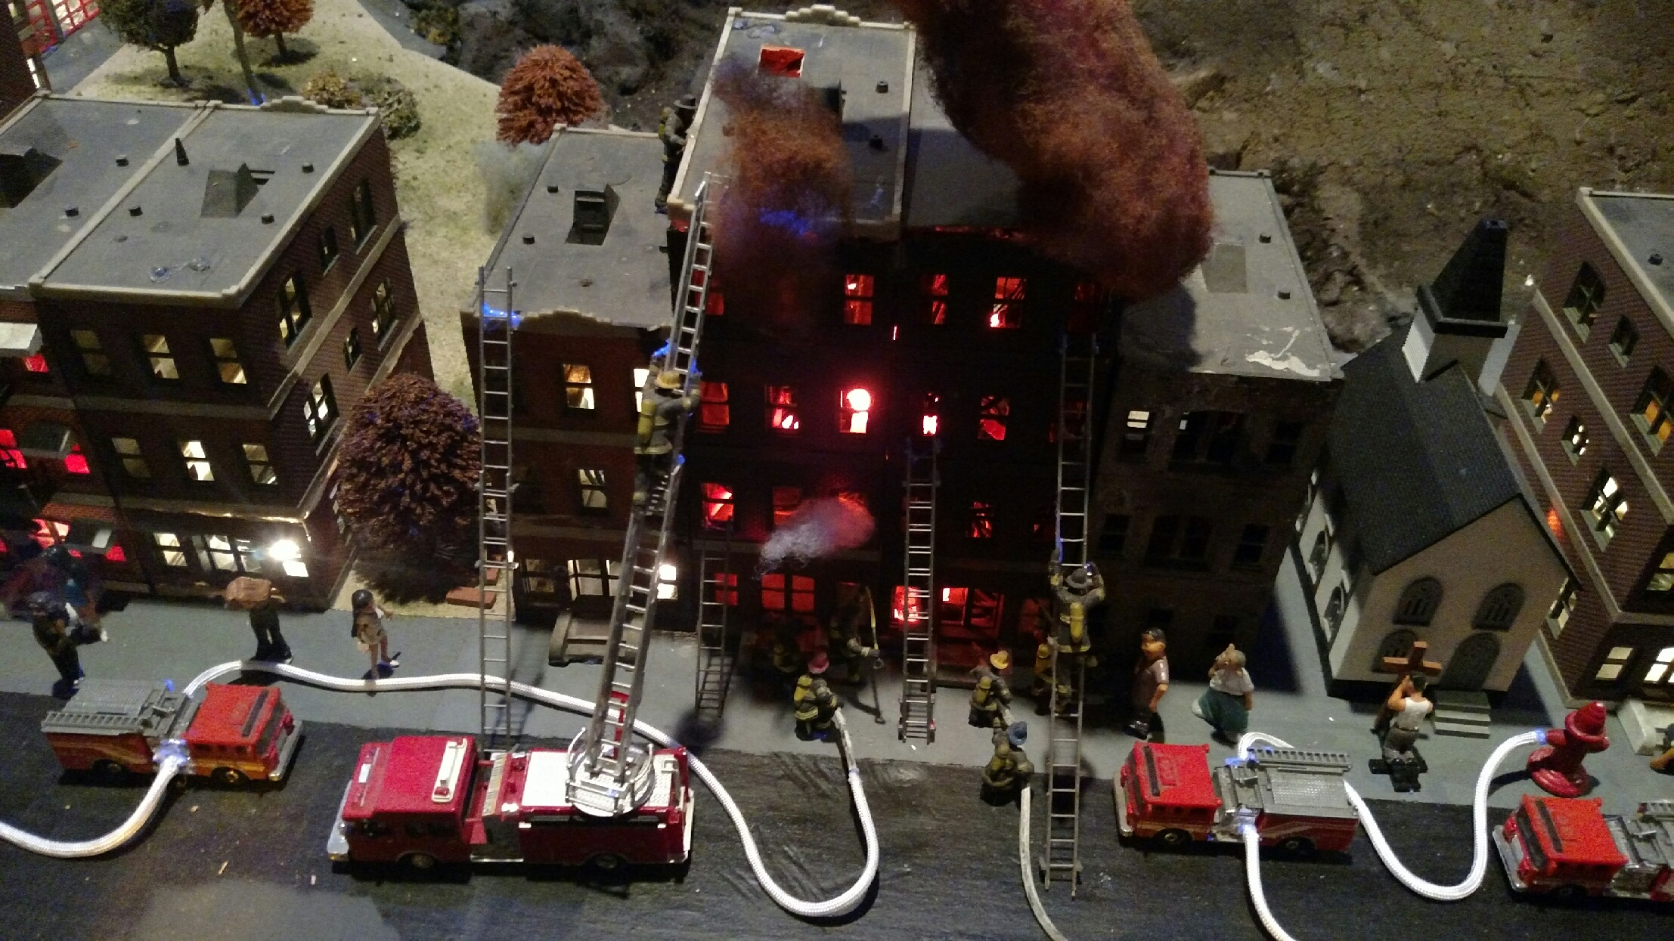
Fire diorama at the Train Garden at Baltimore Engine Company 45. Photo by member Frank San Severino

Reminders
Friday December 16th, 2016
1830 hrs buffet, 2000 hrs meeting
Presentation Member Rick Conway on more Lynn Fire & Apparatus

Meeting is for Members and Applicants only, no guests admitted!
Car pool if you can! Please note that parking is very limited and carpooling is encouraged! Parking is available in Wayne Alarms lot and a lot on the side street.

By Order Of the President Newsletter Editor
David Parr Frank San Severino

A future issue of the Line Box will cover the Cambridge 10th alarm fire
Saturday Dec. 3rd in an upcoming issue.

10-236 Berkshire Street

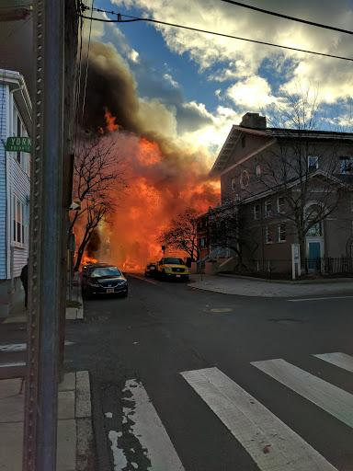
Photo courtesy of Peter Osborne

