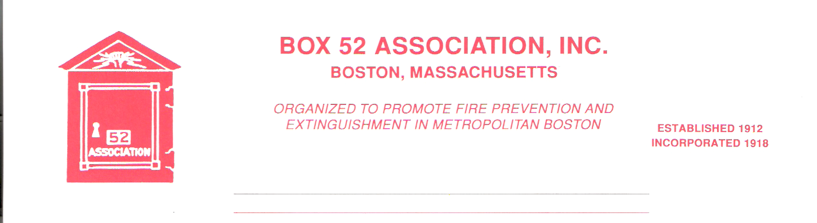
OFFICERS DIRECTORS
PRESIDENT David Parr Jeff Brown
Dave.parr@verizon.net Robert Fitz Jr.
VICE Thomas Brophy Frank Barry
PRESIDENT thomasbrophy25@comcast.net Benjamin Marra
SECRETARY Michael Kass Anthony Scrima
michaelkass@rcn.com Robert Wilker
TREASURER William H. Wilderman – 617-212-8186
Bwilderman@firefire.com
Mailing Box 52 Association
Website: www.Box52.org Address: c/o William H. Wilderman E-Mail: thelinebox@hotmail.com PO Box 848
Medford, Ma. 02155-0009

General Order # 1,029 September 2017

September 2017 Meeting

DATE: Friday September 15th

LOCATION: FEMA USAR MA-Task Force 1 HQ Beverly

TIME: 1800 Hours Apparatus & FEMA Display
1900 Hours Meeting

PROGRAM: “History of the Detroit Fire Dept.” Presented by
Chief David Traiforos.
A Sandwich Collation will be served.

DIRECTIONS TO MEETING SITE
Take 128 north towards Gloucester to exit 20 (Route 1A North). After you go under 128 take the first LEFT at the light on to Conant St. Go approx. 1/3rd mile and take a RIGHT on to Rte. 97 North at the lights, Take 97 north for about 1 mile. On the left will be a sign for Beverly Airport (L.P. Henderson Rd.). Turn LEFT onto Henderson Rd. The first driveway on your RIGHT will go through a gate into the firm Army NIKE Base. Go straight through the gate to the rear if the Base. Training site is next to the new large building with the American Flag.

May Meeting
Our bi-annual bus trip took place on May 13th under grey skies. 40 members and guests enjoyed touring the Departments of the Pioneer Valley. At each stop we were greeted warmly and were able to get numerous apparatus photos. And for the rail fans on the bus, we even arranged to have Norfolk Southern Auto Rack Train #28N from Chicago to Ayer to make an appearance in Orange! It was a great day and a lot of laughs! The 2019 trip will be to a major metropolitan area fire department.

Guest Speaker
Our guest speaker this month is no stranger to Box 52. He has presented several shows on the Detroit Fire Department for us. He retired as Chief of the Franklin Park, IL Fire Department and has been a historian of the DFD for over twenty years.

Good & Welfare
Member Steve Walsh is facing another serious medical issue. Our thoughts and prayers are with Steve for a speedy recovery.
Members Bill Noonan and Rick Conway are both recovering from knee surgery.
Member Douglas Boudrow has decided to move down Mass. Ave from Lexington Fire to Cambridge Fire, good luck Doug. The editor is going to miss you!.

Membership
The application of Mr. Brian Harrington will be voted on at the September meeting. Mr. Harrington is a retired Deputy Fire Chief from the Salem Fire Department.

Line Box
By now you should have all received the summer edition of the Line Box. We are still seeking an additional researcher/writer to join us. If you are interested, please contact me at box52boston@hotmail.com

Dues
It’s that time of year again…..the dues bill for this coming year! Those of you that receive the General Order by email will receive a separate dues invoice via USPS. Please make every effort to pay promptly. Any member having a problem can speak with the Treasurer or any member of the Board.

FEMA MA-TF1 Deploys to Texas
All photos courtesy of MA-TF1

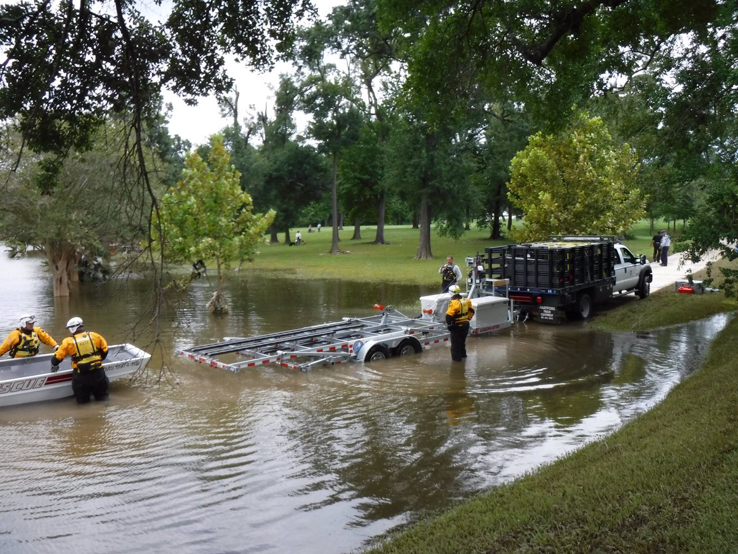
TF-1 getting ready to operate in Katy, Texas

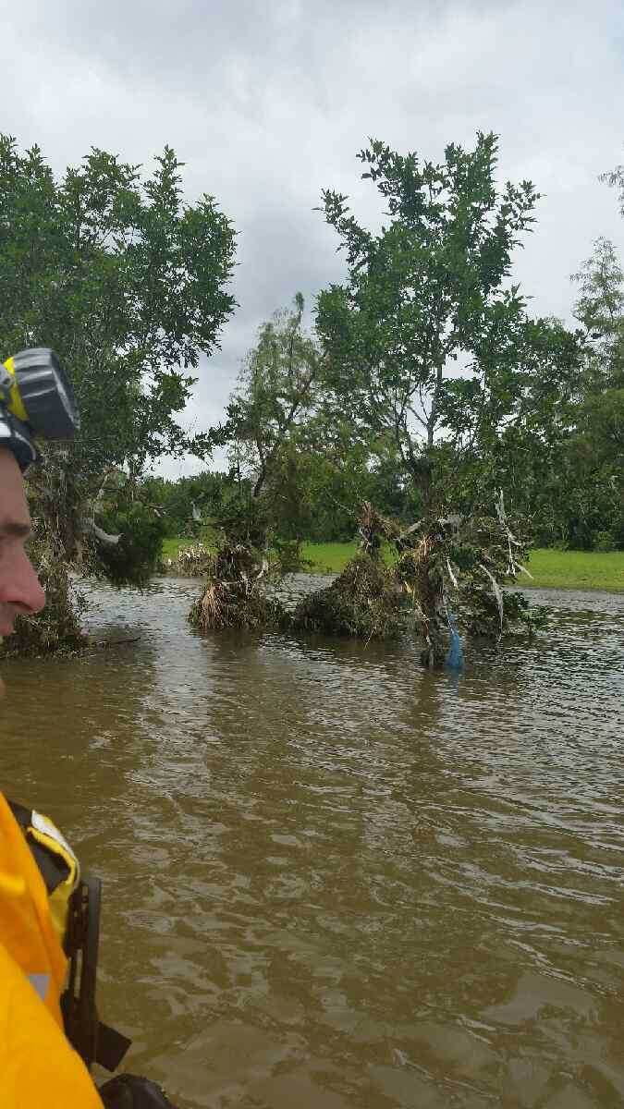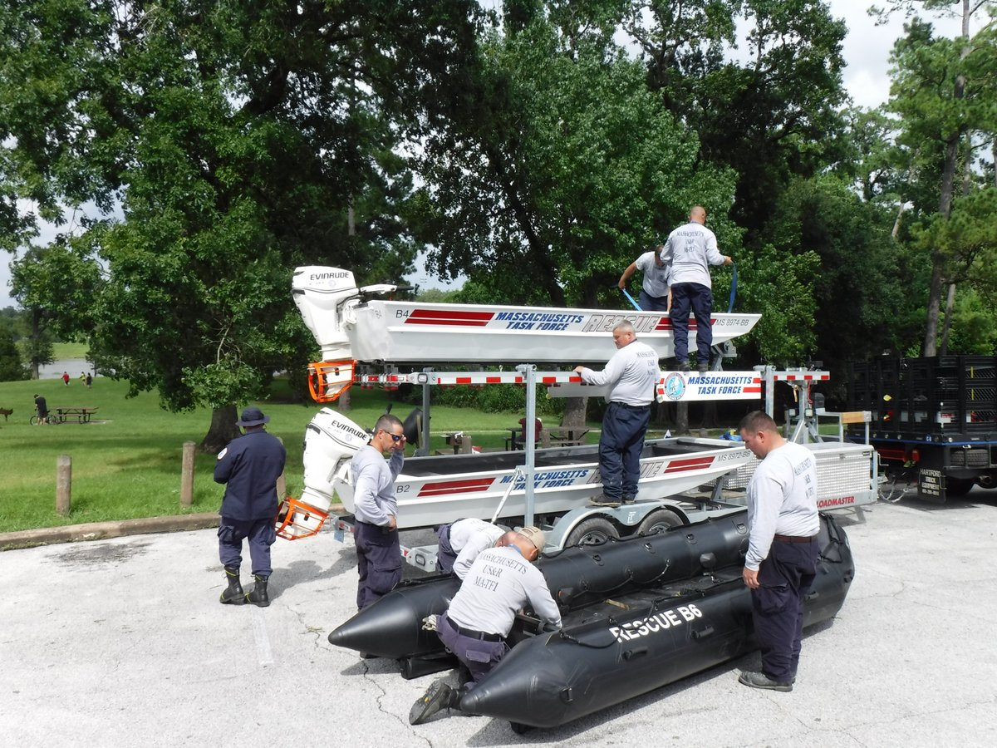

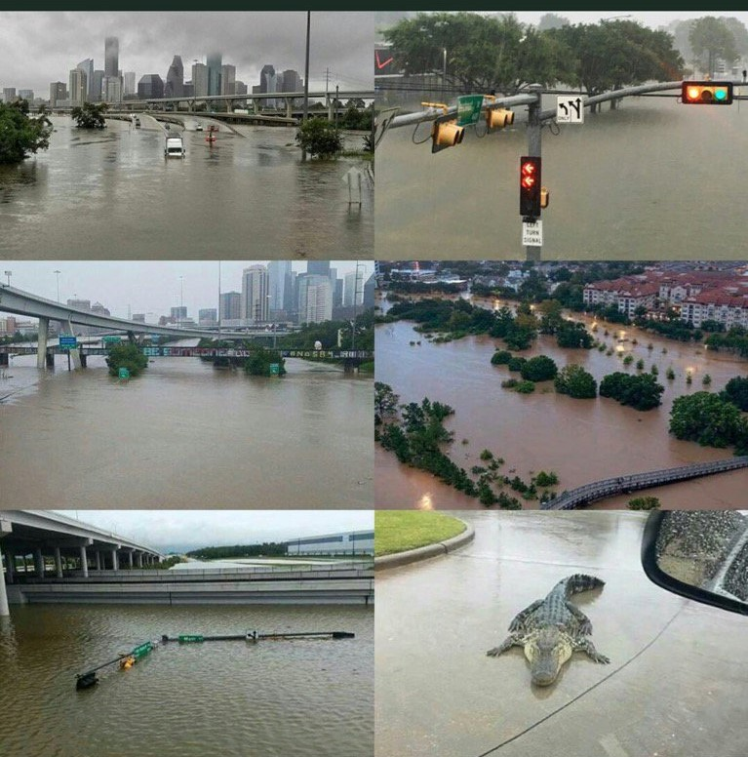

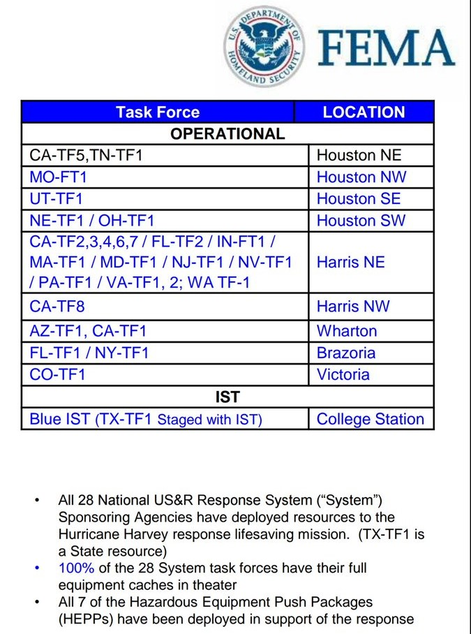

REMINDERS
- Meeting Friday September 15th at Beverly
1800 Hrs. Apparatus & FEMA display
1900 Hrs. Meeting with sandwich’s served
- Friday Sept. 22nd 1000-1400 Hrs. Annual Open House
At Greenwood Emergency Vehicle’s

By Order of the President Newsletter Editor
David Parr Frank San Severino

