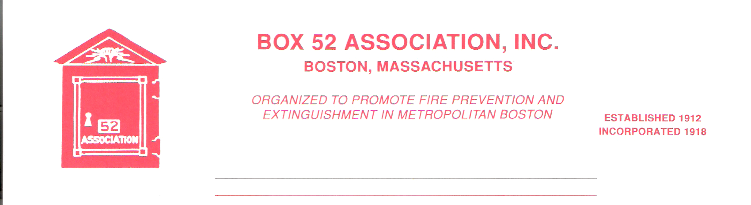
OFFICERS DIRECTORS

PRESIDENT Owen R. Carrigan- 781-646-7622 Thomas Tully
attycarrigan@yahoo.com Alan Macdonald

VICE David Parr Patrick O’Connor
PRESIDENT dave.parr@verizon.net Paul Romano
SECRETARY Michael Kass – 508-875-1725 George Taglieri
michaelkass@rcn.com Thomas Brophy
TREASURER William H. Wilderman – 617-212-8186
Bwilderman@firefire.com

General Order #954 March 2009

March 2009 Meeting

DATE: Friday, March 20th, 2009

LOCATION: Maplewood Place, 295 Broadway, Rt. 99, Malden
Between Plainfield Ave & Fulton St. Meeting will
be held in the Hamilton Room on the first floor.
Enter from the # 3 side. Parking in the rear or on
Street.

TIME: 2000 Hrs.

PROGRAM: “Fire and Brimstone: Auxiliary Firefighter to Chaplain and
all points in between.” Presented by member, Dave
Aiken,

GET WELL WISHES
Several members are on the mend after recent injuries and hospital stays:
John Galla, who suffered an on duty injury. Dick Weixler who was recently hospitalized.

FEBUARY MEETING
Member Paul Boudreau present a very interesting and informative talk on the changes to the Metro-Fire radio system and other changes to fire department radio frequencies. A copy of his hand out can be found in the Line Box.

GUEST SPEAKER
Our guest speaker for the evening will be member Dave Aiken. Dave has held every rank in the fire service from Auxiliary Firefighter to Chief of Department. Sean Cardinal O’Malley ordained Dave a Deacon in the Catholic Church, after four years of study. Dave served as the Fire Chief for 12 years for the Town of Yarmouth. He now serves as Chaplain for several organizations.

WEBSITE
Member John Galla, has done an excellent job on getting our website up and operational. Please take a moment and surf over to www.box52.org.

LOCAL FIRE DEPARTMENTS FISCAL SITUATIONS
With the on going budget problems facing public safety agencies across the state. Members are reminded that the IFBA Code Of Fire Buffing under Purpose states: “To act as a citizens; public relations group for the Fire Department. An interested and enlightened citizenry becomes the strongest bulwark against unfair criticism of any emergency service.” Each member should do their utmost to assist their hometown agencies against layoffs, station closings or other reductions in levels of service.

EXEMPT MEMBERSHIP
At the last Board of Directors meeting, member Fred Thumith was voted into Exempt Membership. It was learned that Fred, a longtime member is confined to his home.

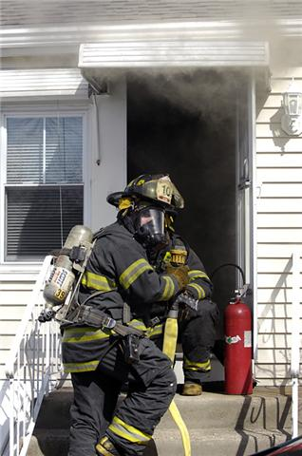
Lynn, MA. First line in door at a Working Fire. J. Daley photo

REMINDER
Meeting Friday March 20th at 2000 hrs Malden. Presentation by member Dave Aiken

By Order Of The President Newsletter Editor
Owen Carrigan Frank San Severino

